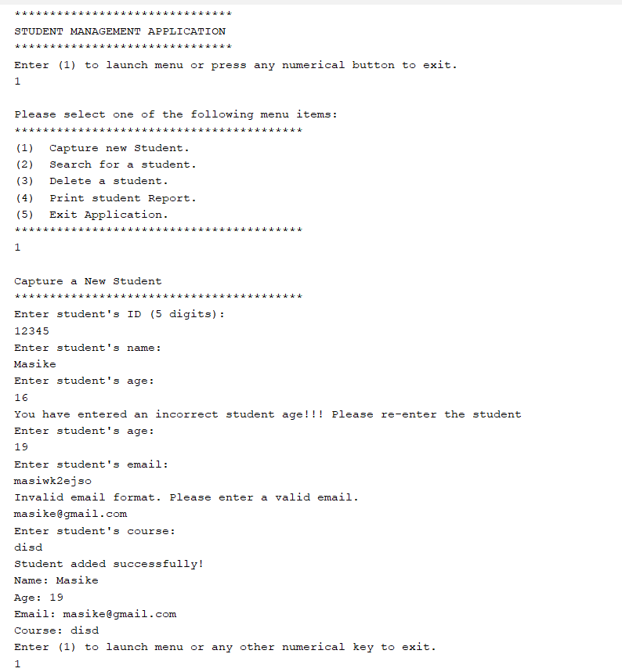

Figure 1Adding Student and Error Handling for text/values

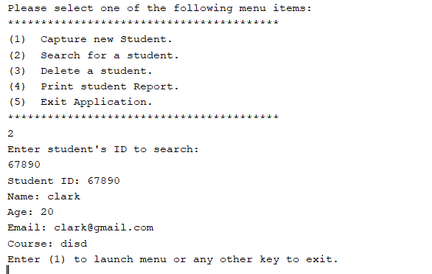

Figure 2Search for Student based on StudentId

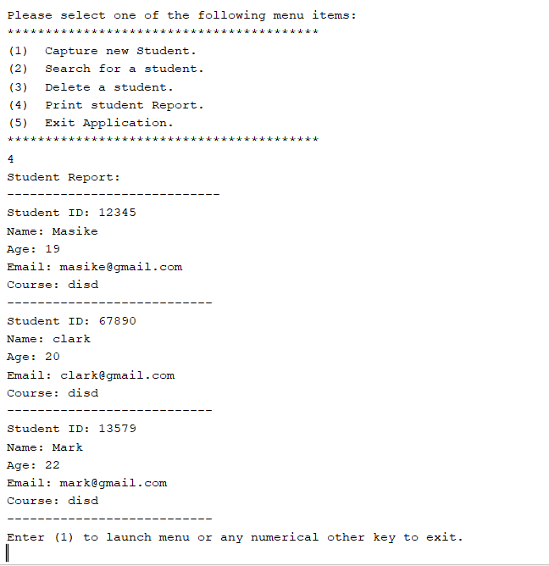

Figure 3Display Students in Report form

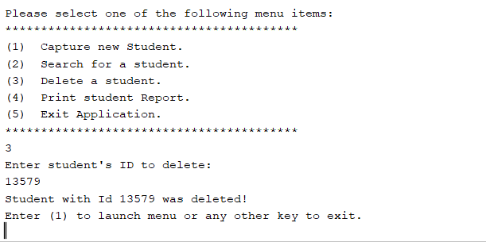

Figure 4Delete Student by StudentID

Figure 5Exiting SMApp key  
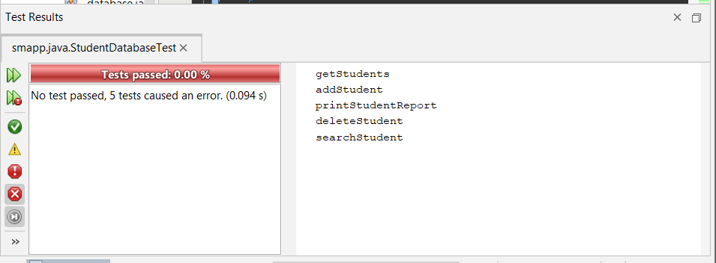

Figure 6Failing Junit Testing

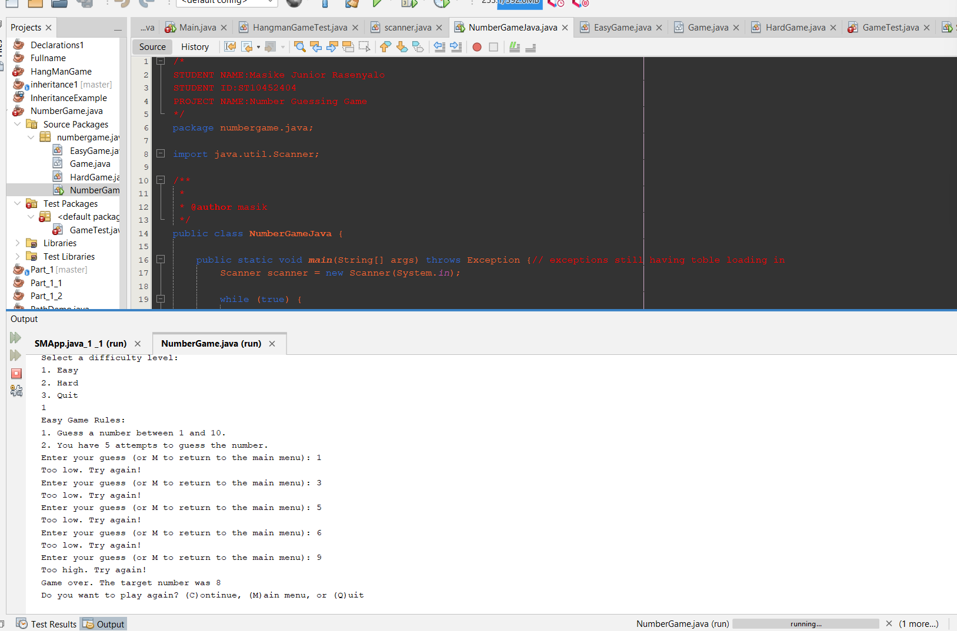

Figure 7Game Try

Figure 8Game Success

Figure 9Game Quit